**Lab Exercise 5– Terraform Variables with Command**

**Line Arguments Objective:**

Learn how to pass values to Terraform variables using command line arguments.

**Prerequisites:**

* Terraform installed on your machine.
* Basic knowledge of Terraform variables.

**Steps:**

**1. Create a Terraform Directory:**

# mkdir terraform-variables cd terraform-variables

1. **Create Terraform Configuration Files:**

* + Create a file named main.tf:

# main.tf

resource

"aws_instance"

"example"

{

instance_type

=

var

.

instance_type

ami

=

var

.

ami

}

terraform

{

required_providers

{

aws

=

{

source

=

"hashicorp/aws"

version

=

"5.31.0"

}

}

}

* + Create a file named variables.tf:

# variables.tf

|  |
| --- |
| variable "region" { description = "AWS region" default = "us-west-2"  } |
|  |
| variable "ami" { description = "AMI ID" default = "ami-008fe2fc65df48dac"  } variable "instance_type" { description = "EC2 Instance Type" default = "t2.micro"  } |

1. **Use Command Line Arguments:**

* + Open a terminal and navigate to your Terraform project directory.
  + Run the terraform init command:

# terraform init

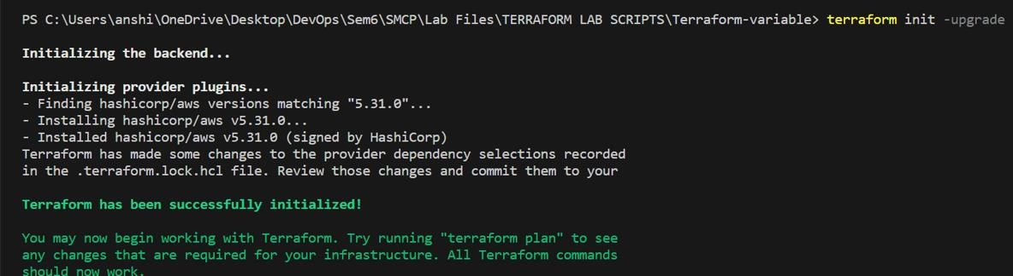

• Run the terraform apply command with command line arguments to set variable values:

# terraform apply -var 'ami=ami-12345678' -var 'instance_type=t2.small

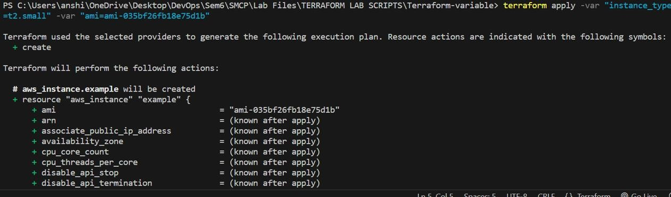

1. **Test and Verify:**

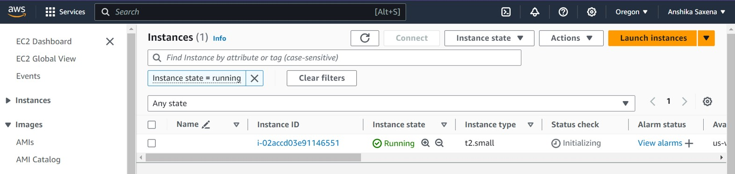

1. **Clean Up:**

After testing, you can clean up resources:

# terraform destroy

